**Survey For OUCers’ Future Plan**

In this report, I will analyze the questionnaire.

1.Gender?

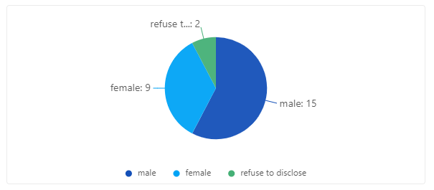

We surveyed 26 students, including 15 boys and 9 girls. At the same time, two participants refused to disclose their gender.

2.Do you plan to have postgraduate study?

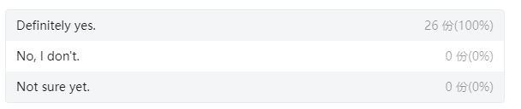

This table reveal that all of the participants want to have postgraduate study.

1. Where do you want to study / work ?

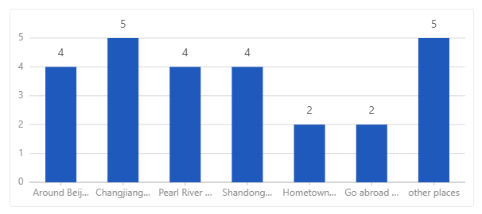

On the whole, people have no special preference for regions.

4.What's your expected annual salary?

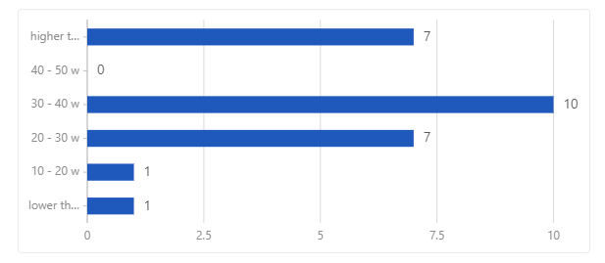

Most participants expect an annual salary of more than 200,000 yuan.

Surprisingly, I found that no participants want an annual salary of 40 - 50w yuan. Maybe it is caused by too few samples.

In conclude, I think today’s students commonly have a higher expectation for salary compared with the past.

5.Do you have the idea of entering the system？

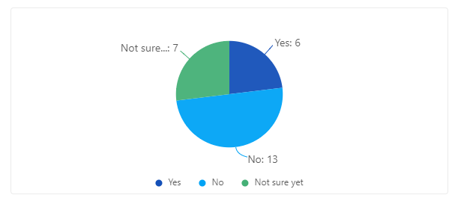

From the pie chart above, we can know that only about 25 percent of the whole participants have a clear goal for entering the system.

6.Do you have the idea of starting a business？

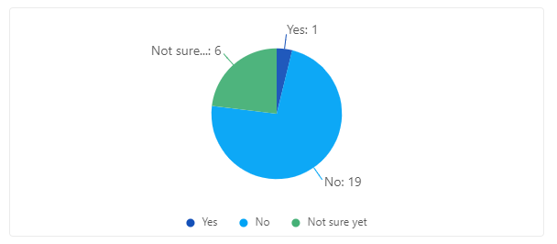

When it comes to starting a business, the result is similar to the previous question.

People who don’t have such idea dominate the result.

7.Do you plan to pursue a doctorate?

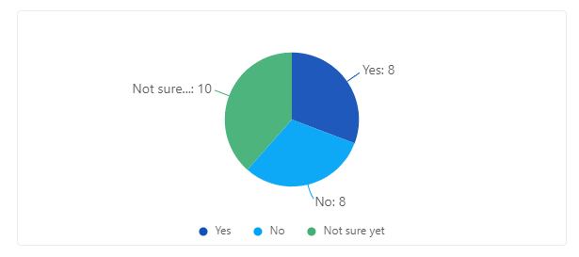

This is a funny result. The question is composed of three choices: “Yes”,” No”, and “Not sure yet”.

From the pie chart we can clearly see that each part share about 33 percent of the whole pie chart.

8.When do you plan to get married?

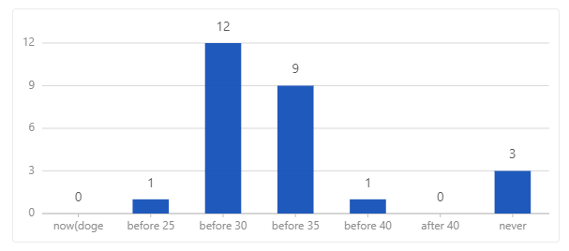

About 80 percent of the participants plan to get married before 30 and 35.

Meanwhile, I found that there are three participants never want to get married.

9.How many children do you plan to bring up?

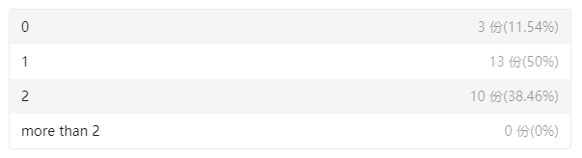

Let’s watch at this table. Do you think the result is very similar to the previous one?

Also, I found that a participant chose “never get married” and “want one child”.

10.What do you value most when choosing a job？

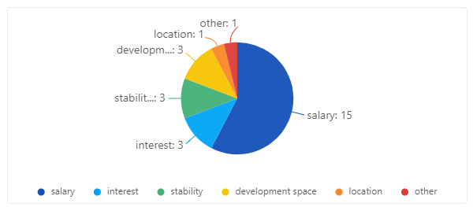

This pie chart reveal that the salary factor still dominate the reason for choosing jobs.

However, more and more people start to focus on other factors such as interest, stability, and development space.

11.Are you satisfied with your current situation？

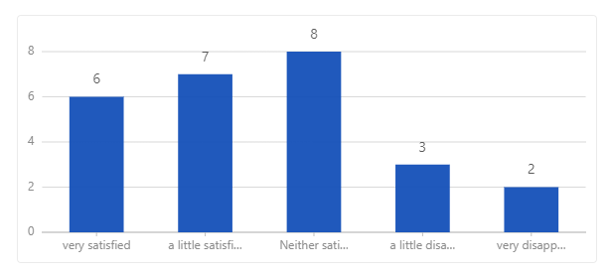

Well, some people are satisfied with now’s situation, and others are some degree of disappointed.

12.Are you confident about your future？

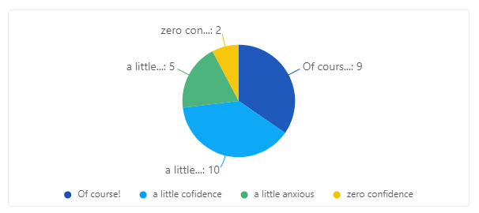

Over one-third of the participants are very confident about their future, who are the main constitute of the people satisfied with current situation.